МИНИСТЕРСТВО НАУКИ И ВЫСШЕГО ОБРАЗОВАНИЯ  
РОССИЙСКОЙ ФЕДЕРАЦИИ

федеральное государственное автономное   
образовательное учреждение высшего образования  
«Самарский национальный исследовательский университет   
имени академика С.П. Королева»

(Самарский университет)

Институт информатики, математики и электроники

Факультет информатики  
Кафедра суперкомпьютеров и общей информатики

**Отчет по лабораторным работам № 1**

Дисциплина: «Enterprise Systems Development (Методы проектирования и поддержки требований к программному обеспечению)»

Тип предприятия: **«Social Network»**

Выполнила: Курбатова О.В.

Группа: 6133-010402D

Самара 2021

# Assignment #1 Specification of system requirements. Use Case diagram

Objective: To study the basic features for creating and editing use case diagrams

## Tasks

1. Choose one of the company type from the excel list or use your own company type. In the course of the assignments, you will have to describe and suggest some business processes automating of the selected company.

2. Define list of high-level customer’s needs, which going to be solved by the information system implementation. Not less than 5 use cases in list.

3. Create Glossary of subject domain terms, which you will use next.

4. Create Use Case diagram for the described use cases. Diagram should include situation with at least two actors collaboration. Create Use Case diagram image (png/jpeg/gif). Add image to doc report (see template in <https://github.com/j-avdeev/EnterpriseSystemsDevelopment/tree/2021/Assignment%20Reports%20Template>)

**Assignment #1. Use Case diagram**

**Task 1**

The chosen company type is Social Network - Interactive multiplayer website, the content of the network is filling by users.

**Task 2**

1. Social network website allows you to create profile;
2. Social network website allows you to view your own profile and other user’s profile;
3. Social network website allows you to add photo to your profile;
4. Social network website allows you to send, edit and delete message;
5. Social network website allows you to publish, edit and delete posts on wall;
6. Social network website allows you to read news;
7. Social network website allows you to invite your friends;

**Task 3**

Glossary:

Social network website – system, which allows users send messages, share posts and photos, read news.

User – user of the system, who is interested music instruments and buy music instruments online (using website)

Profile – User’s page with information about user’s life, work, intrests

Administrator – person, who manages the home page, control Users content , may change information in the website.

Photo – multimedia file, jpg or png format, max size 5 Mb.

Message – text, max 140 symbols.

Post – text message or multimedia content, which publish on website.

**Task 4**

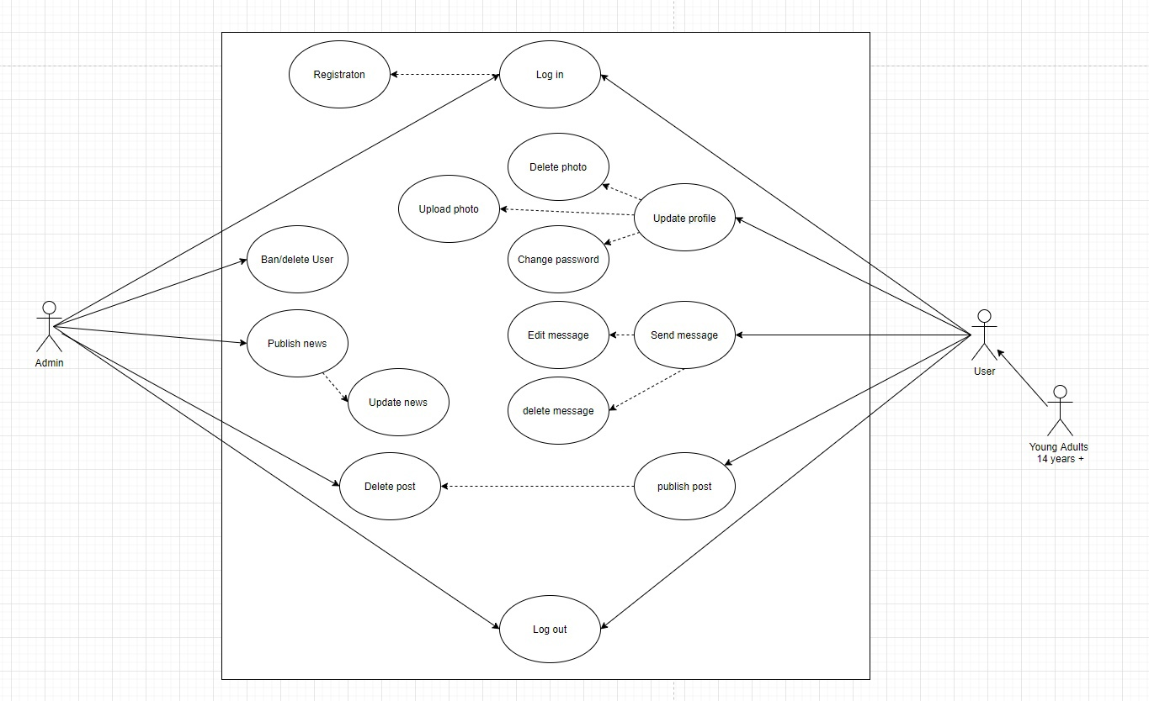

Figure 1 – Social Network chain. Use Case diagram